For more information:
Katie Phelan
BRAVE Public Relations
404.233.3993
kphelan@emailbrave.com

FOR IMMEDIATE RELEASE

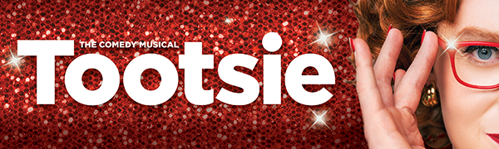

THE TONY AWARD®-WINNING MUSICAL IS COMING TO
ATLANTA JAN. 25-30, 2022
TICKETS ON SALE OCT. 29

ATLANTA (October 19, 2021) – TOOTSIE, the hilarious Tony Award-winning musical, is coming to the Fox Theatre in Atlanta for a limited one-week engagement from Jan. 25-30, 2022. To celebrate Fifth Third Bank Broadway in Atlanta’s 40th anniversary season, a select number of $40 tickets will be sold for each performance. Tickets will be available at FoxTheatre.org/Tootsie.

Call it “musical comedy heaven” (Rolling Stone). Call it “the most uproarious new musical in years!” (The Hollywood Reporter). Call it Tootsie! This laugh-out-loud love letter to the theater tells the story of Michael Dorsey, a talented but difficult actor who struggles to find work until one show-stopping act of desperation lands him the role of a lifetime. Featuring a hilarious Tony®-winning book by Robert Horn and an outrageously clever score by 2018 Tony-winner David Yazbek (The Band’s Visit, Dirty Rotten Scoundrels), this New York Times Critic’s Pick is “a joyful delight” (The Washington Post) that’s “so packed with punchlines, it should be called a jokebox musical!” (Bloomberg). “In these turbulent times, when the world seems out of balance, we need a place to let the good times roll,” raves Rolling Stone. “Tootsie is it!”

The creative team for Tootsie includes director Dave Solomon (Broadway associate director), Broadway choreography by Denis Jones, associate choreographer Chip Abbott. The design team for Tootsie includes original scenic designer David Rockwell, tour scenic designer Christine Peters, costume designer William Ivey Long, associate costume designer Christopher Vergara, lighting designer Donald Holder, associate lighting designers Vivien Leone & Coby Chasman-Beck and assistant lighting designer Colleen Doherty, sound designer Brian Ronan, associate sound designer Cody Spencer, hair and wig design by Paul Huntley, assistant hair and wig designer Loryn Pretorius. make-up design by Angelina Avallone. Casting is by Binder Casting, Chad Murnane CSA. Supervising Music Supervisor Andrea Grody, Music Supervision by Dean Sharenow, vocal & incidental arrangements by Andrea Grody, dance arrangements by David Chase, orchestrations by Simon Hale, and music coordination by Talitha Fehr.

Tootsie is based on the story by Don McGuire and Larry Gelbart and the Columbia Pictures Motion Picture produced by Punch Productions and starring Dustin Hoffman. The National Tour of Tootsie is produced and managed by TROIKA Entertainment.

Information about the venue’s enhanced health and safety measures can be found on the Fox Theatre website. The health and well-being of audiences, touring productions, staff and all venue personnel remains top priority.

For more information, visit tootsiemusical.com

# # #

